SUBMISSION FORM FOR FORMAL OBJECTION / REPRESENTATION OF SUPPORT NORTH LANARKSHIRE LOCAL DEVELOPMENT PLAN MODIFIED PROPOSED PLAN

Town and Country Planning (Scotland) Act 1997
Planning etc (Scotland) Act 2006

This form must be submitted by 4.15pm on 5 April 2019

- Objections and representations of support for the modified proposed plan must be made in writing using this form.

- If you choose to object, support or comment on the proposed plan, you MUST tell us what you are objecting, supporting or commenting on (your representation). You MUST also tell us the changes you would like to see as a result of your representation (modifications sought). Please do not tick a box without commenting further.

- Limited additional material can be attached to a completed form.

- Any person, group or organisation, either individually or collectively, can object or make a representation of support.

- Submissions on separate matters/issues must be made on separate forms (i.e. one form for each submission). Download further forms here.

- All submissions will be available for public inspection. Your name and comments will be published as part of our statutory duty to produce the Modified Local Development Plan.

- We recommend that electronic submissions are made in PDF format

- If making a handwritten submission, please use BLACK INK.

- Please read the guidance notes (attached) carefully before completing this form.

Please note:

Contributions received during the initial Proposed Plan Consultation (January – March 2017) have been taken into account. Previous submissions CANNOT be taken forward through this stage of the process, as this stage relates to the modified proposed plan.
If you have made comment previously on the initial proposed plan and now wish to comment on the modified proposed plan, please use this form.

Email the completed form to: Yourplan@northlan.gov.uk

Or post to: Enterprise & Place, North Lanarkshire Council, Fleming House, 2 Tryst Road, Cumbernauld, G67 1JW

Your privacy
You need to know that we will process your submission and your data as part of our statutory duty to prepare the Local Development Plan Modified Proposed Plan.
As part of our statutory requirements, your comments cannot be treated as confidential and will be made available for public inspection. Whilst this does not include personal data (contact details and address), it does include your name and the content of your submission.
We have to keep your contact details and address after the consultation period has ended so that we can keep in touch with you throughout the process.
We will submit the Modified Proposed Plan, with a report of all objections and our response to them, to Scottish Ministers for examination. They will appoint a reporter or reporters to carry out the examination. We will share your personal data with the appointed reporter or reporters as they may make requests for further information or decide to hold a hearing to explore issues further.
If you do not want us to use your details for this purpose, you will need to withdraw your submission and we will not be able to take your comments into account.
We are committed to protecting the privacy and confidentiality of any personal information that we hold. This privacy notice will tell you how we look after your personal information tell you about your rights.
https://www.northlanarkshire.gov.uk/planconsultation

Name
Company
Address
Town
Postcode
Email

Phone

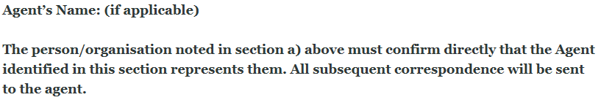

Name
Company
Address
Town
Postcode
Email

Phone

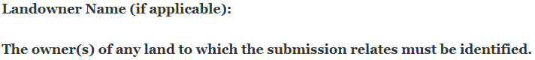

Name
Company
Address
Town
Postcode
Email

Phone

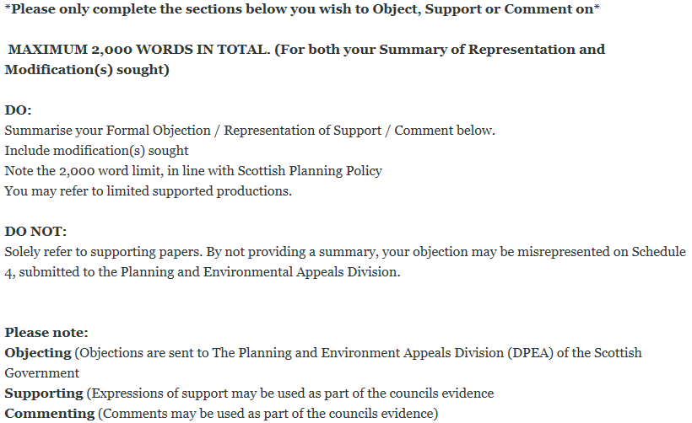
IMPORTANT: Please do not tick any box below without commenting further:
IF YOU CHOOSE TO OBJECT, SUPPORT OR COMMENT ON ANY OF THE BELOW, YOU MUST TELL US WHAT YOU ARE OBJECTING, SUPPORTING OR COMMENTING ON (Your representation).
YOU MUST ALSO TELL US THE CHANGES YOU WOULD LIKE TO SEE AS A RESULT OF YOUR REPRESENTATION (Modifications sought)
☐ Objecting
☐ Supporting
☐ Commenting

Type your comments here:
Representation:

Modification(s) Sought be Those Submitting Representation:

☐ Objecting
☐ Supporting
☐ Commenting

Type your comments here:
Representation:

Modification(s) Sought be Those Submitting Representation:

☐ Objecting
☐ Supporting
☐ Commenting

Type your comments here:
Representation:

Modification(s) Sought be Those Submitting Representation:

☐ Objecting
☐ Supporting
☐ Commenting

Type your comments here:
Representation:

Modification(s) Sought be Those Submitting Representation:

☐ Objecting
☐ Supporting
☐ Commenting

Type your comments here:
Representation:

Modification(s) Sought be Those Submitting Representation:

☐ Objecting
☐ Supporting
☐ Commenting

Type your comments here:
Representation:

Modification(s) Sought be Those Submitting Representation:

☐ Objecting
☐ Supporting
☐ Commenting

Type your comments here:
Representation:

Modification(s) Sought be Those Submitting Representation:

☐ Objecting
☐ Supporting
☐ Commenting

Type your comments here:
Representation:

Modification(s) Sought be Those Submitting Representation:

☐ Objecting
☐ Supporting
☐ Commenting

Type your comments here:
Representation:

Modification(s) Sought be Those Submitting Representation:

☐ Objecting
☐ Supporting
☐ Commenting

Type your comments here:
Representation:

Modification(s) Sought be Those Submitting Representation:

☐ Objecting
☐ Supporting
☐ Commenting

Type your comments here:
Representation:

Modification(s) Sought be Those Submitting Representation:

☐ Objecting
☐ Supporting
☐ Commenting

Type your comments here:
Representation:

Modification(s) Sought be Those Submitting Representation:

☐ Objecting
☐ Supporting
☐ Commenting

Type your comments here:
Representation:

Modification(s) Sought be Those Submitting Representation:

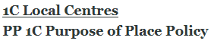
☐ Objecting
☐ Supporting
☐ Commenting

Type your comments here:
Representation:

Modification(s) Sought be Those Submitting Representation:

☐ Objecting
☐ Supporting
☐ Commenting

Type your comments here:
Representation:

Modification(s) Sought be Those Submitting Representation:

☐ Objecting
☐ Supporting
☐ Commenting

Type your comments here:
Representation:

Modification(s) Sought be Those Submitting Representation:

☐ Objecting
☐ Supporting
☐ Commenting

Type your comments here:
Representation:

Modification(s) Sought be Those Submitting Representation:

☐ Objecting
☐ Supporting
☐ Commenting

Type your comments here:
Representation:

Modification(s) Sought be Those Submitting Representation:

☐ Objecting
☐ Supporting
☐ Commenting

Type your comments here:
Representation:

Modification(s) Sought be Those Submitting Representation:

☐ Objecting
☐ Supporting
☐ Commenting

Type your comments here:
Representation:

Modification(s) Sought be Those Submitting Representation:

☐ Objecting
☐ Supporting
☐ Commenting

Type your comments here:
Representation:

Modification(s) Sought be Those Submitting Representation:

☐ Objecting
☐ Supporting
☐ Commenting

Type your comments here:
Representation:

Modification(s) Sought be Those Submitting Representation:

☐ Objecting
☐ Supporting
☐ Commenting

Type your comments here:
Representation:

Modification(s) Sought be Those Submitting Representation:

☐ Objecting
☐ Supporting
☐ Commenting

Type your comments here:
Representation:

Modification(s) Sought be Those Submitting Representation:

☐ Objecting
☐ Supporting
☐ Commenting

Type your comments here:
Representation:

Modification(s) Sought be Those Submitting Representation:

☐ Objecting
☐ Supporting
☐ Commenting

Type your comments here:
Representation:

Modification(s) Sought be Those Submitting Representation:

☐ Objecting
☐ Supporting
☐ Commenting

Type your comments here:
Representation:

Modification(s) Sought be Those Submitting Representation:

☐ Objecting
☐ Supporting
☐ Commenting

Type your comments here:
Representation:

Modification(s) Sought be Those Submitting Representation
☐ Objecting
☐ Supporting
☐ Commenting

Type your comments here:
Representation:

Modification(s) Sought be Those Submitting Representation:

☐ Objecting
☐ Supporting
☐ Commenting

Type your comments here:
Representation:

Modification(s) Sought be Those Submitting Representation:

☐ Objecting
☐ Supporting
☐ Commenting

Type your comments here:
Representation:

Modification(s) Sought be Those Submitting Representation:

☐ Objecting
☐ Supporting
☐ Commenting

Type your comments here:
Representation:

Modification(s) Sought be Those Submitting Representation
☐ Objecting
☐ Supporting
☐ Commenting

Type your comments here:
Representation:

Modification(s) Sought be Those Submitting Representation:

☐ Objecting
☐ Supporting
☐ Commenting

Type your comments here:
Representation:

Modification(s) Sought be Those Submitting Representation:

☐ Objecting
☐ Supporting
☐ Commenting

Type your comments here:
Representation:

Modification(s) Sought be Those Submitting Representation:

☐ Objecting
☐ Supporting
☐ Commenting

Type your comments here:
Representation:

Modification(s) Sought be Those Submitting Representation:

☐ Objecting
☐ Supporting
☐ Commenting

Type your comments here:
Representation:

Modification(s) Sought be Those Submitting Representation:

☐ Objecting
☐ Supporting
☐ Commenting

Type your comments here:
Representation:

Modification(s) Sought be Those Submitting Representation:

☐ Objecting
☐ Supporting
☐ Commenting

Type your comments here:
Representation:

Modification(s) Sought be Those Submitting Representation:

☐ Objecting
☐ Supporting
☐ Commenting

Type your comments here:
Representation:

Modification(s) Sought be Those Submitting Representation:

☐ By written submissions
☐ By presenting your views at a Local Plan Examination – Hearing Session (Attendance is at the invitation of the Scottish Government Reporter)

REMINDER:
Please do not submit this form without commenting:
IF YOU CHOOSE TO OBJECT, SUPPORT OR COMMENT, YOU MUST TELL US WHAT YOU ARE OBJECTING, SUPPORTING OR COMMENTING ON (Your representation).
YOU MUST ALSO TELL US THE CHANGES YOU WOULD LIKE TO SEE AS A RESULT OF YOUR REPRESENTATION (Modifications sought)

What happens next?
The Council will consider all submissions and, if necessary, a Local Development Plan Examination (LDPE) will be held, where an independently appointed Scottish Government Reporter will consider unresolved formal objections. There is a presumption that oral evidence will take the form of a Hearing.
If you have opted to present your views at the LDPE, you may be invited to present your case in person or through an agent. Attendance is at the invitation of the Scottish Government Reporter. At the LDPE, you must provide the necessary copies of your formal objection and supporting information.
If you have opted for your formal objection to be dealt with as a written submission, you need not attend the LDPE as your response can be considered by Written Representations
What Will Happen To Your Submission (Formal Objection or Representation of Support)
You will receive an acknowledgement of your representation/formal objection. All submissions will be available for public inspection in Enterprise & Place, Fleming House, 2 Tryst Road, Cumbernauld, G67 1JW, after the closing date and at the time of any Local Development Plan Examination.
After the Local Development Plan Examination
The Reporter will issue a Report of Examination outlining recommendations that the Council must take into account in deciding how to modify the Plan before proceeding to Adoption.

